Rodrigo Garcia-Novoa

Dr. Yiannis Ampatzidis

CSUB MSEIP-2

11 August 2016

**Autonomous and Remote Controlled Robot**

**Introduction:**

The autonomous and remote controlled robot is based off the Arduino microcontroller platform and the use of the Printrbot Play to create a fully 3D-printed frame. The robot consists of the main components: Arduino nano, servo motors, and ultrasonic sensor. The Arduino nano controls the mode of the robot and the three servo motors. The function of two of the three servo motors lies in moving the wheels and one motor in controlling the ultrasonic sensor. The ultrasonic sensor allows for the robot’s autonomous capability by allowing it to monitor objects in its way and navigate around any obstacles. With the use of an infrared remote, the robot could also be manually controlled.

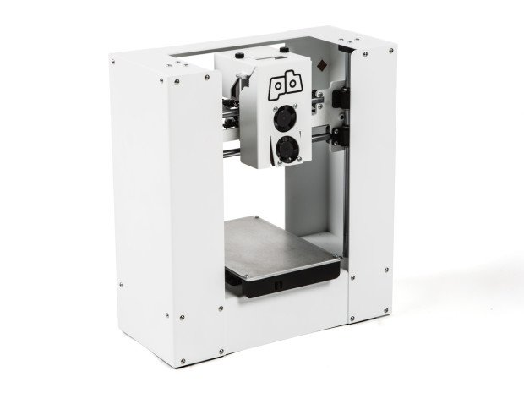

**Materials:**

|  |  |
| --- | --- |
| 3D Printed Parts | Components |
| 1x Front Mount part  1x Rear mount part  1x Speaker cube part  1x Speaker grille part  1x Battery holder part  1X Battery pack part  1x HC-SR04 front part  1x HC-SR04 back part  1x small wheel holder part  1x small wheel holder top part  1x small wheel part  2x main wheel part | 1x Ultrasonic sensor HC-SR04  2x Hi-Tec Servo motor  1x Micro servo motor  1x Arduino Nano rev. 3  1x IR receiver TSOP382  1x Buzzer  6x AAA battery  1x Remote Control |

**Method:**

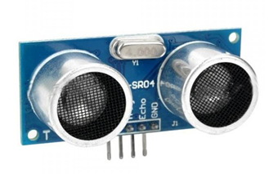The Arduino nano is the main component for the function of the robot. The nano will send and receive signals from the other components and power them. The information received from the ultrasonic sensor will detect objects that its coming close in contact to, so it sends this information back to the nano to perform a calculation that will choose which direction the robot should veer off to while in autonomous mode. The motors will operate directly off this algorithm and will perform the operation of moving forward, backward, left, or right. The micro servo would be in control of the ultrasonic sensor and will help rotate the head to monitor the robot’s surroundings. For the remote controlled function, an infrared receiver will decode the signals from the remote and each button will correspond to their individual functions of moving the robot in different directions or playing music. Overall, the robot could be self or manually operated with the use of a microcontroller and other components.

**Procedure:**

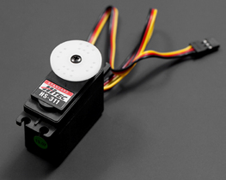Being that the robot is fully 3D printed, the printing time for thirteen parts took an estimated fourteen hours to complete. Due to the imperfection of 3D printers, mistakes could be made while printing the part, so it leads to modifications needed on the final product or the remake of a complete new one. For the servo motors on the wheels, changes also needed to be made from its default settings. At first, the servo motors are only allowed to move a certain degree of motion, but with the removal of these limitations found within the gears of the motors by cutting off plastic tabs that keep them from continuous rotation, they become useful as motors for the wheels. The assembly of the parts also require some improvisation because the 3D printed parts may not perfectly piece together well. I had to add multiple cuts and holes to the finished parts to allow the assembly to flow smoothly. The wiring schematic included soldering many wires to the same power and ground wire.. The program needed to be adjusted to the remote control by reading in the decimal codes given off the remote buttons through the infrared receiver which decodes the buttons signals. By knowing the decimal codes, we can assign each button with its own operation of moving the robot, changing modes, or playing music.

**Results:** Through the testing of the robot by an Arduino Uno and breadboard, all three modes were successful in their functionalities. During autonomous mode, the robot was able to be aware of its surroundings and maneuver its self away from any objects that it may run into. With the manual control, an infrared remote was able to take control of the robot and its functions of modes, directions, and music. Finally, the monitoring mode served its purpose of reacting to any presence of an object that got close to its vision while stationary.

**Conclusion:** At the start of the program, I had never heard or seen an Arduino. I am a Computer Science major and was interested in knowing more about computer engineering concepts. The MSEIP program has helped me learn about microcontrollers and its compatible components like ultrasonic sensors, LCDs, and servo motors. I learned how to use the Arduino software program to upload algorithms to the microcontroller. By having no experience in wiring components or microcontrollers, I feel that I have gained introductory knowledge to microcontrollers and their many applications.



